**1.**[**SharePoint 2013: Getting Started**](https://www.youtube.com/watch?v=FO7oq4bzuo8)

**Three types of Account**

1. **Admin Account**: Site collection Administrator and has for information situation SharePoint site
2. **Contributer Account**: Can Add all existing on SharePoint
3. **Viewer Account**: Read only Access

* To **log in** use URL: <https://eyos2011.sharepoint.com/sites/Demo/SitePages/Home.aspx>

**For user1**

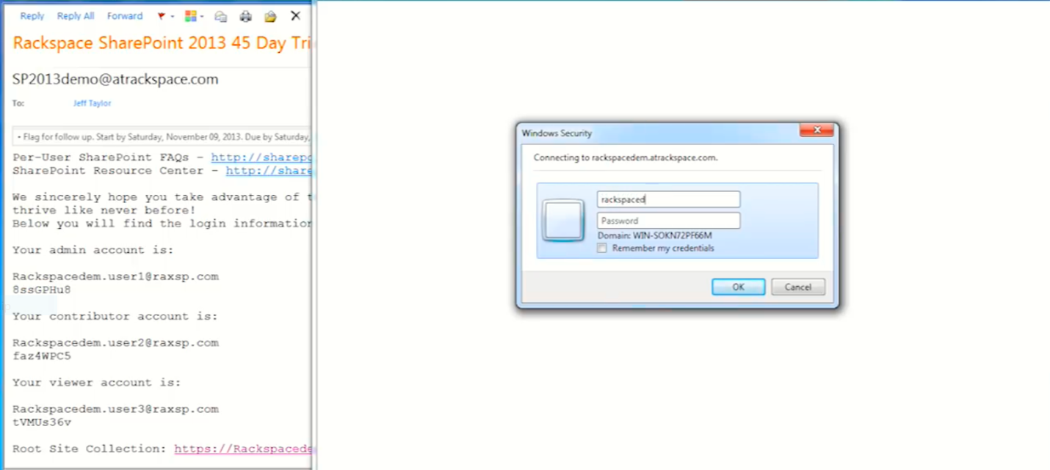

1. **Creating/uploading Documnt**

* Docmunt
* + New /Uploaded document
* Browese
* Select file
* Open
* Ok

1. **Add An Account Called Dept.**

* Library
* Column Name(Dept.)
* Select “Choice”
* In choice box (write the choice dept.)

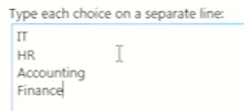

* Default value = null

**Tag stackment**

* Ellipse next to our uploaded file
* Ellipse-> Ellipse->Edit properties

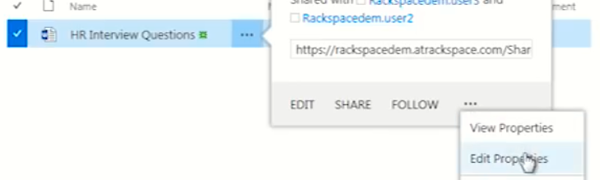

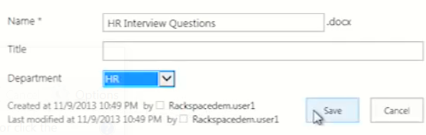

1. **Uploaded by drag and drop**

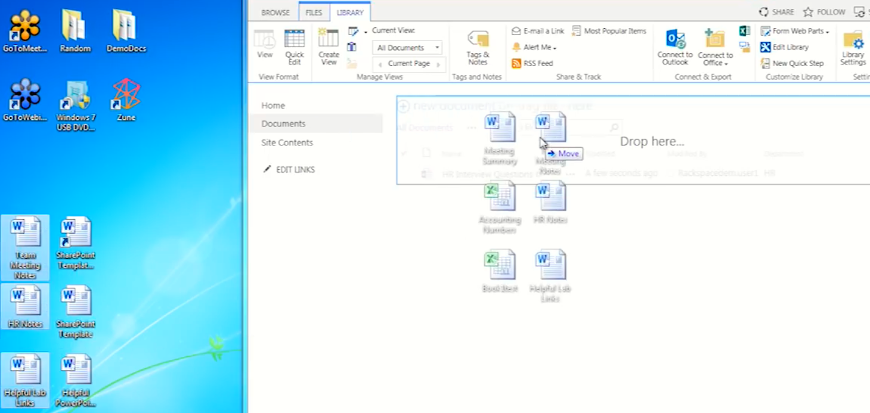

**FAQs**

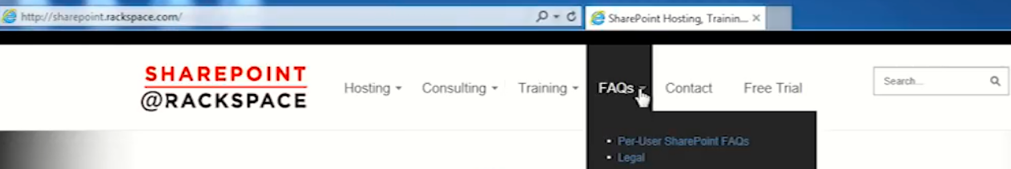

**Some tutorials**

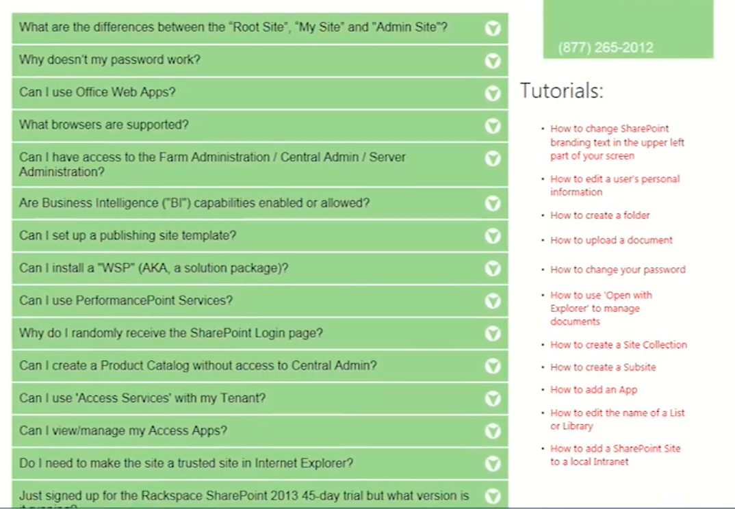

**Put the value of Dept.**

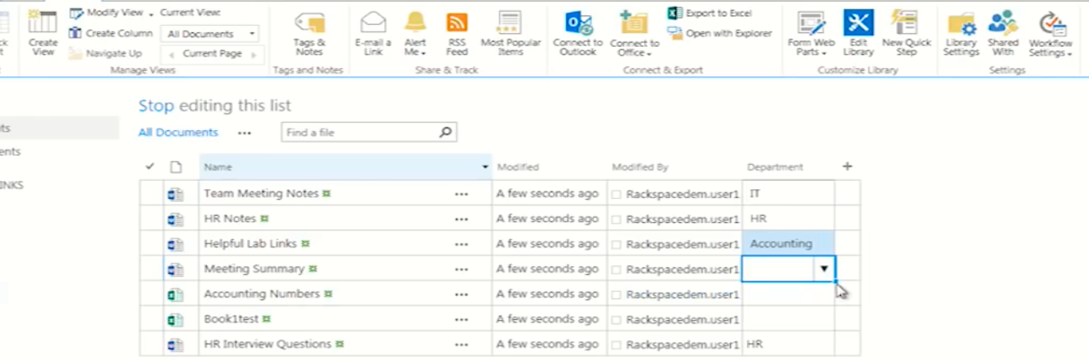

1. **Filtering**

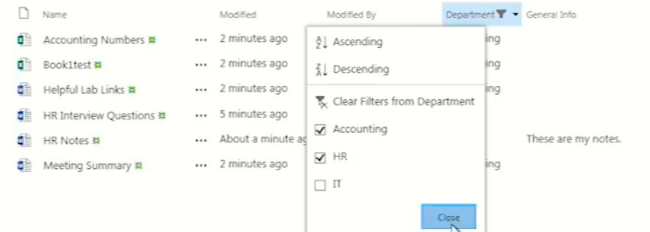

1. **Versioning**

Library->Library settings->Versioning settings->Mejor version->ok

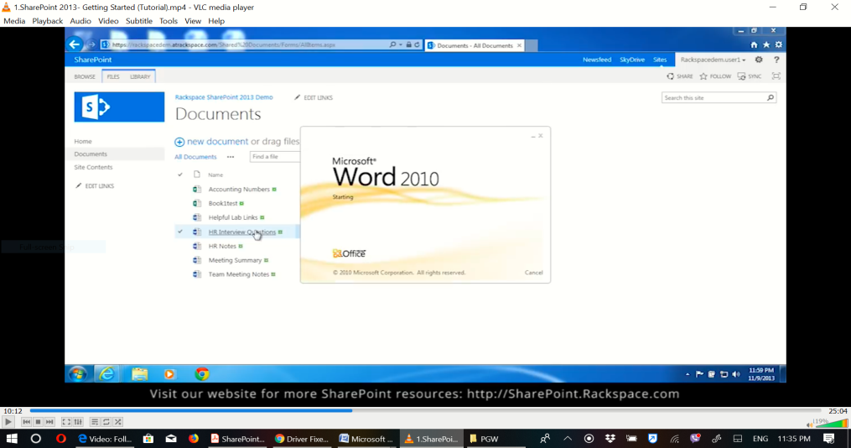

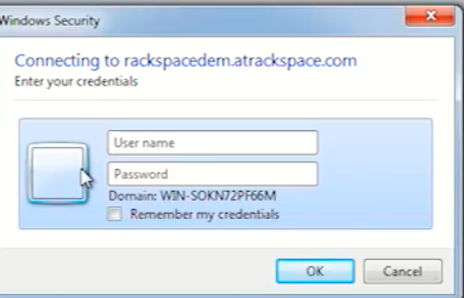

**Write the note**

Eg.This is my first interview question->Save->refresh

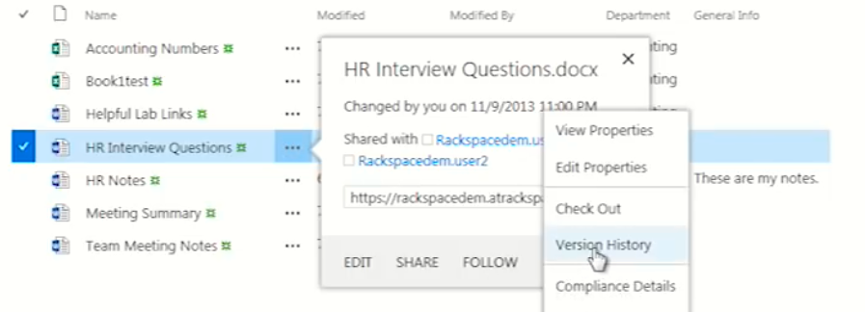

1. **Versioning settings**

Library->library settings->version settings->keep the following num. 5->Ok->document

**Edit**

**Document1**

Page->Edite

**..**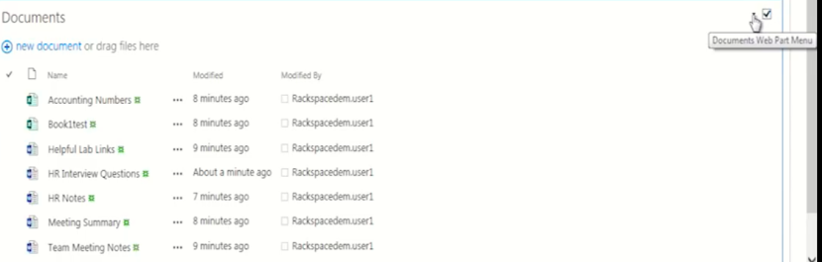

**Edit the current view->**

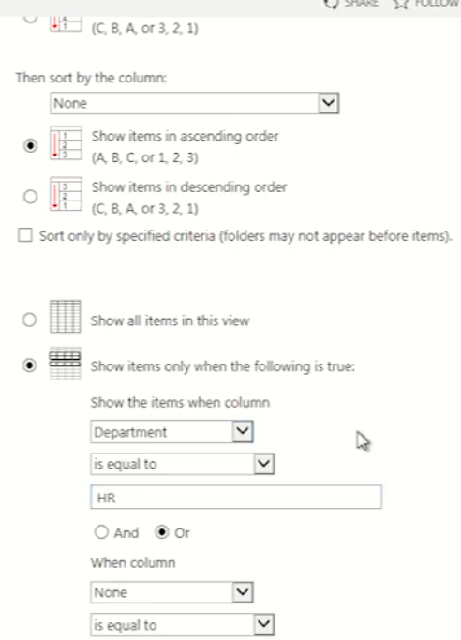

1. **Insert webpart**

Page->edit->Insert webpart->document->Add

Edit it The same to the top

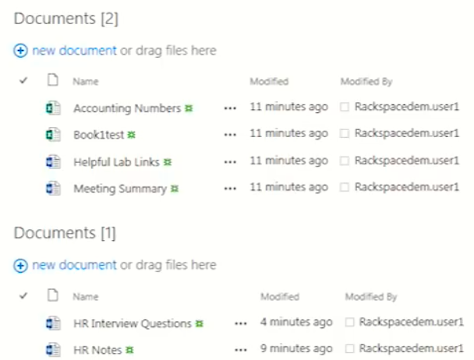

**Edit the first document = HR document**

Page->edit-> C:\Users\Nega\Desktop\paybill\PGW\ww5.png --->web part-> web part properties->Appearance->

C:\Users\Nega\Desktop\paybill\PGW\ww6.png-->apply

**For the other part**

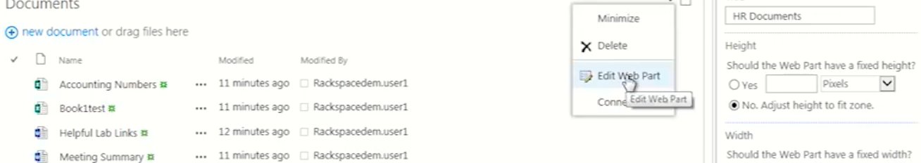

Appearance->…,No toolbar

Then the result be

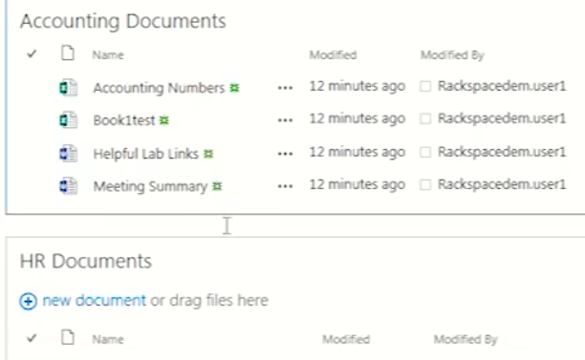

**Share**

Library->SharedWith->

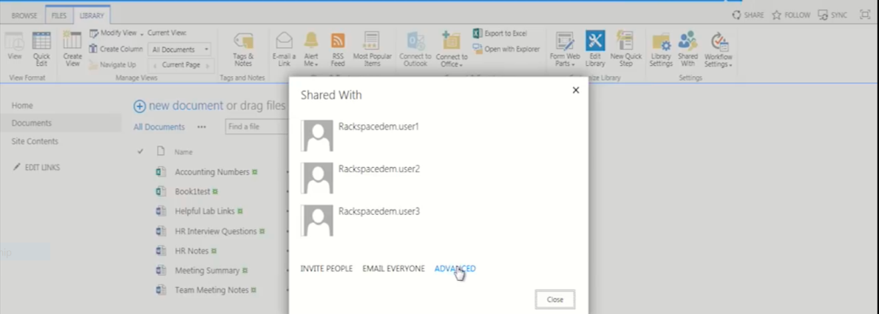

**TO brake information**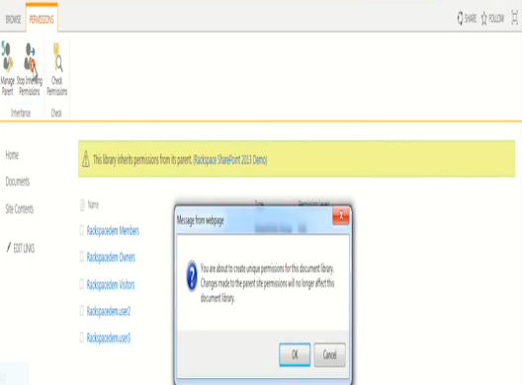

**To delet an access**

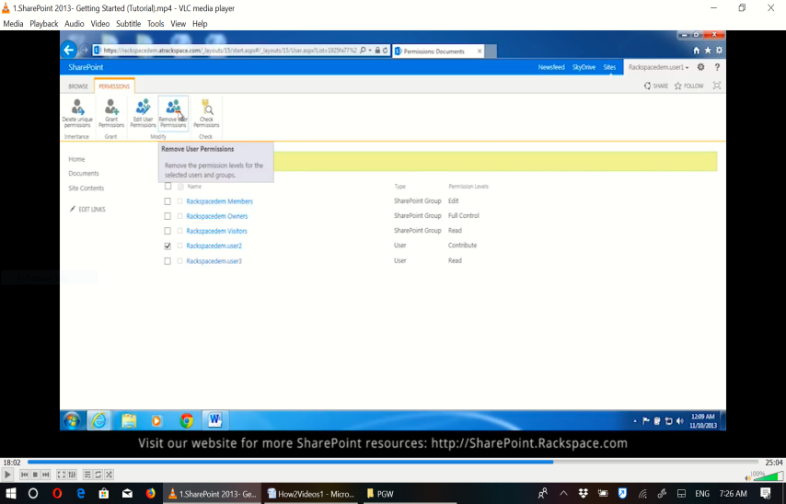

**For user2**

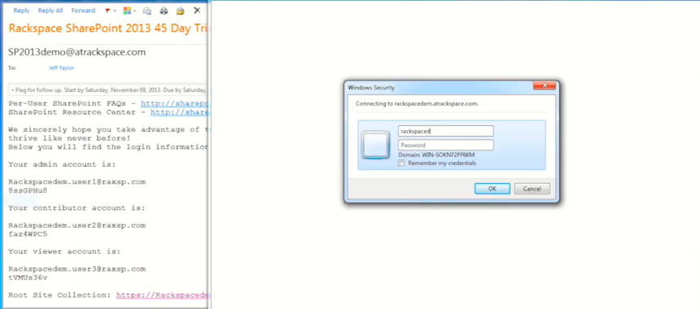

**To get another change**

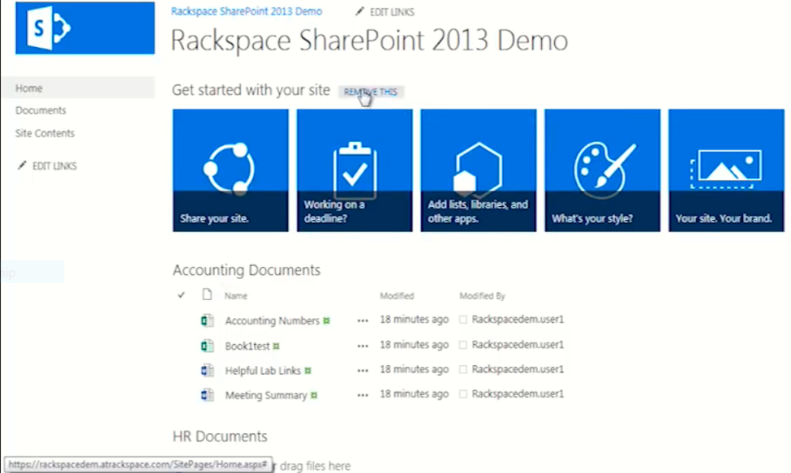

**Add New App**

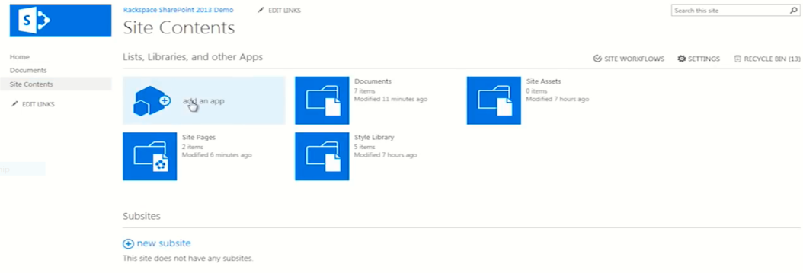

**Example team Calander**

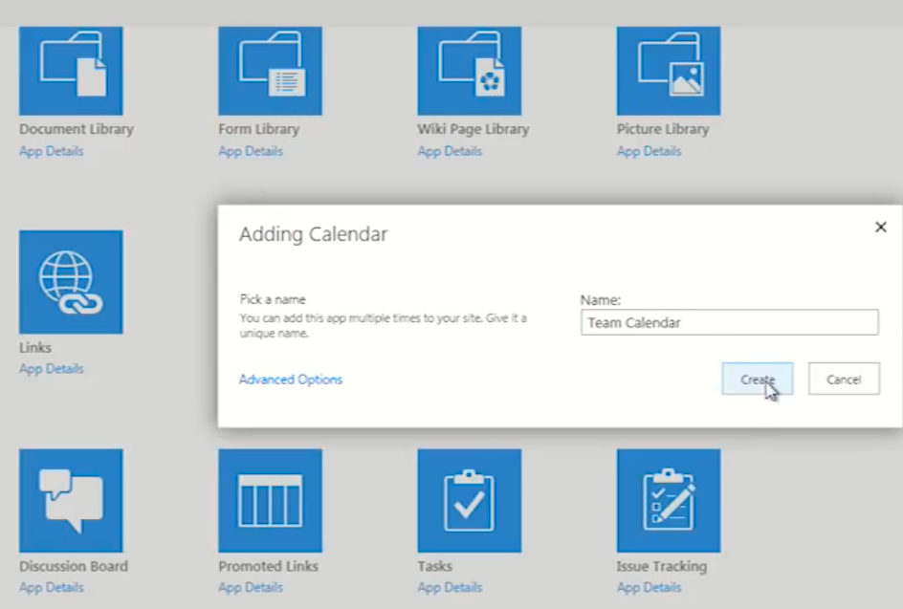

**Open it and add an event**

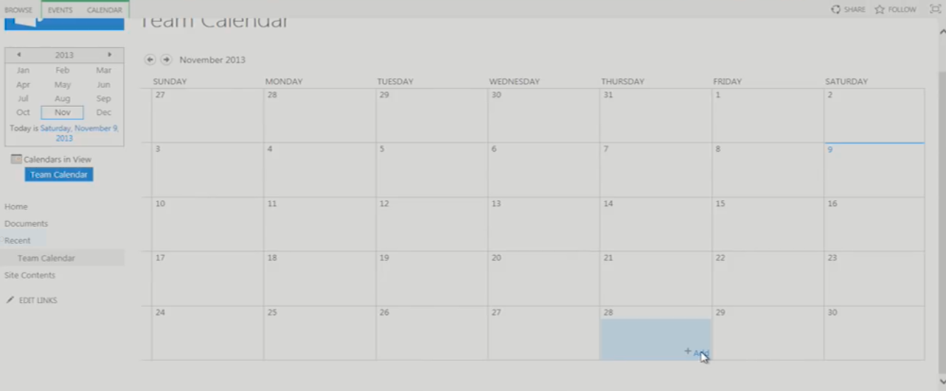

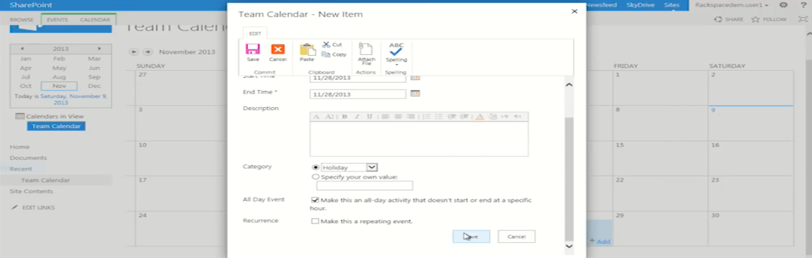

**To change the calander view**

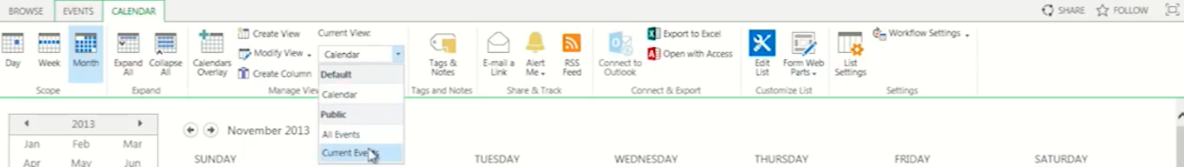

**Then we get**

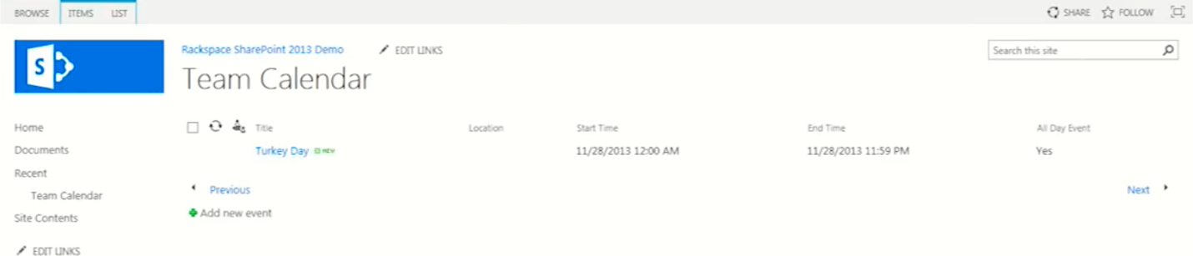

**Add SharePoint in Calander**

Home->page->Edit->Insert->web part->team Calander->Add->

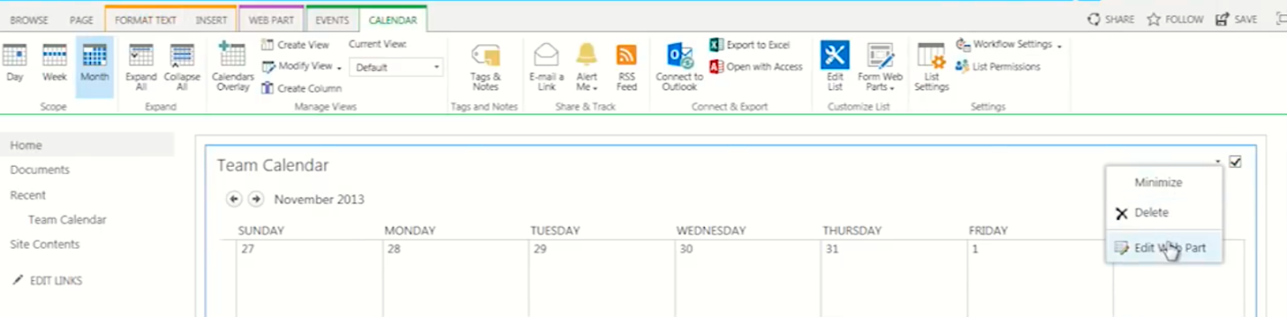

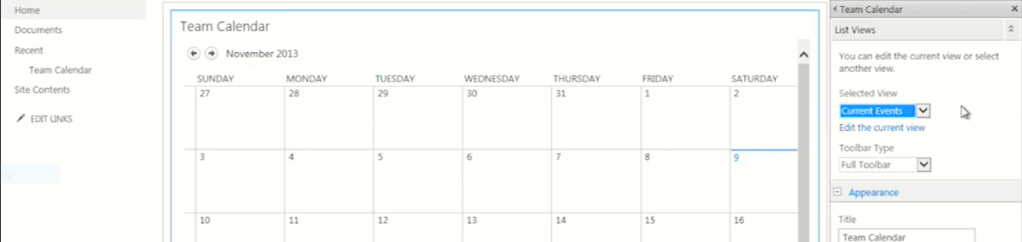



**Then we get the following result**

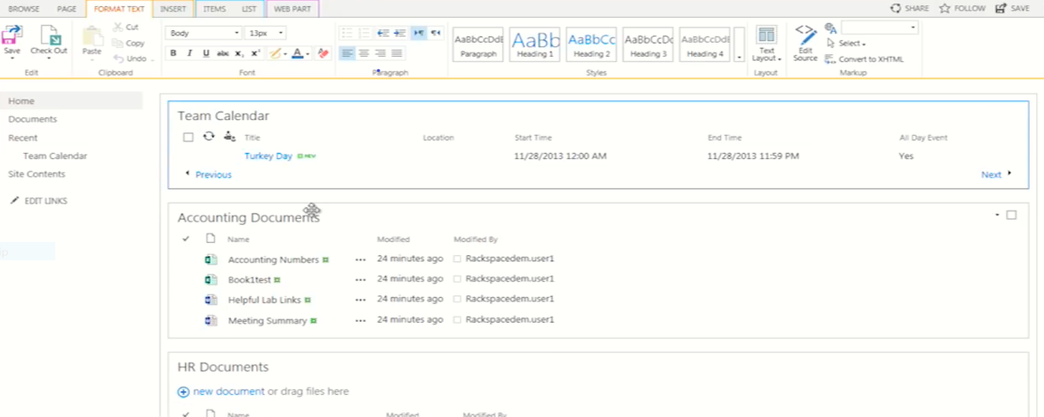

**Creating SubSite for only one department: eg For IT**

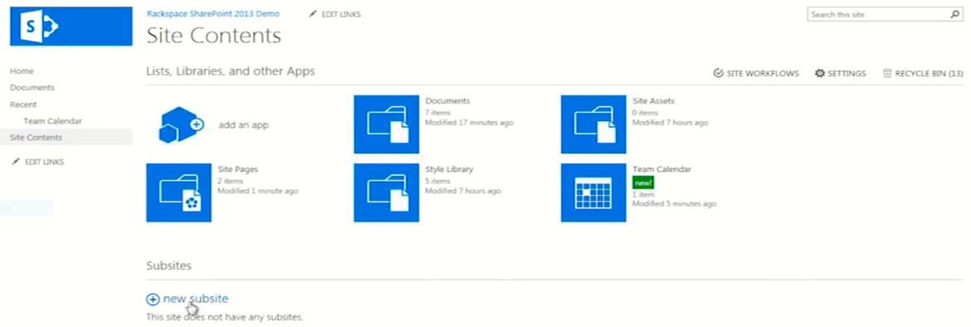

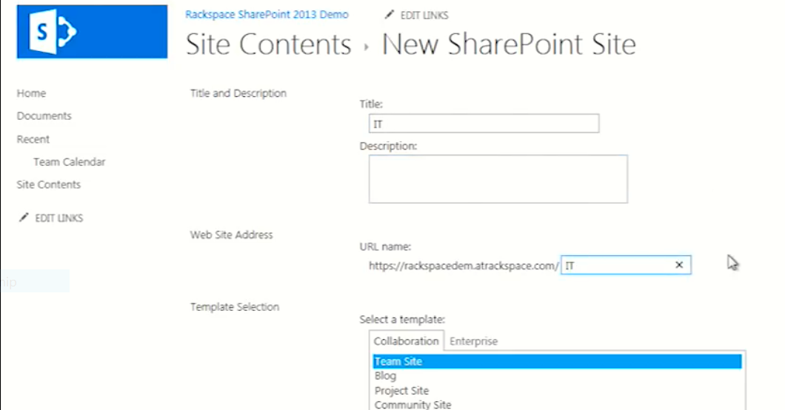

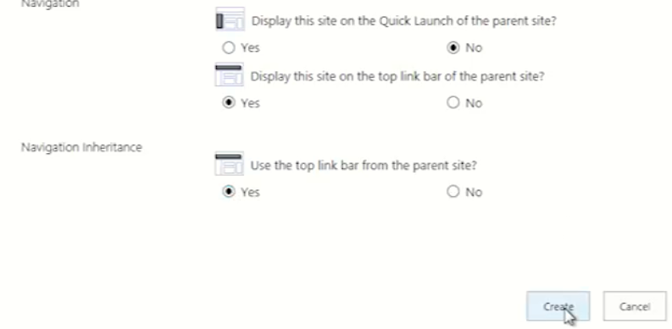

**Then we get**

